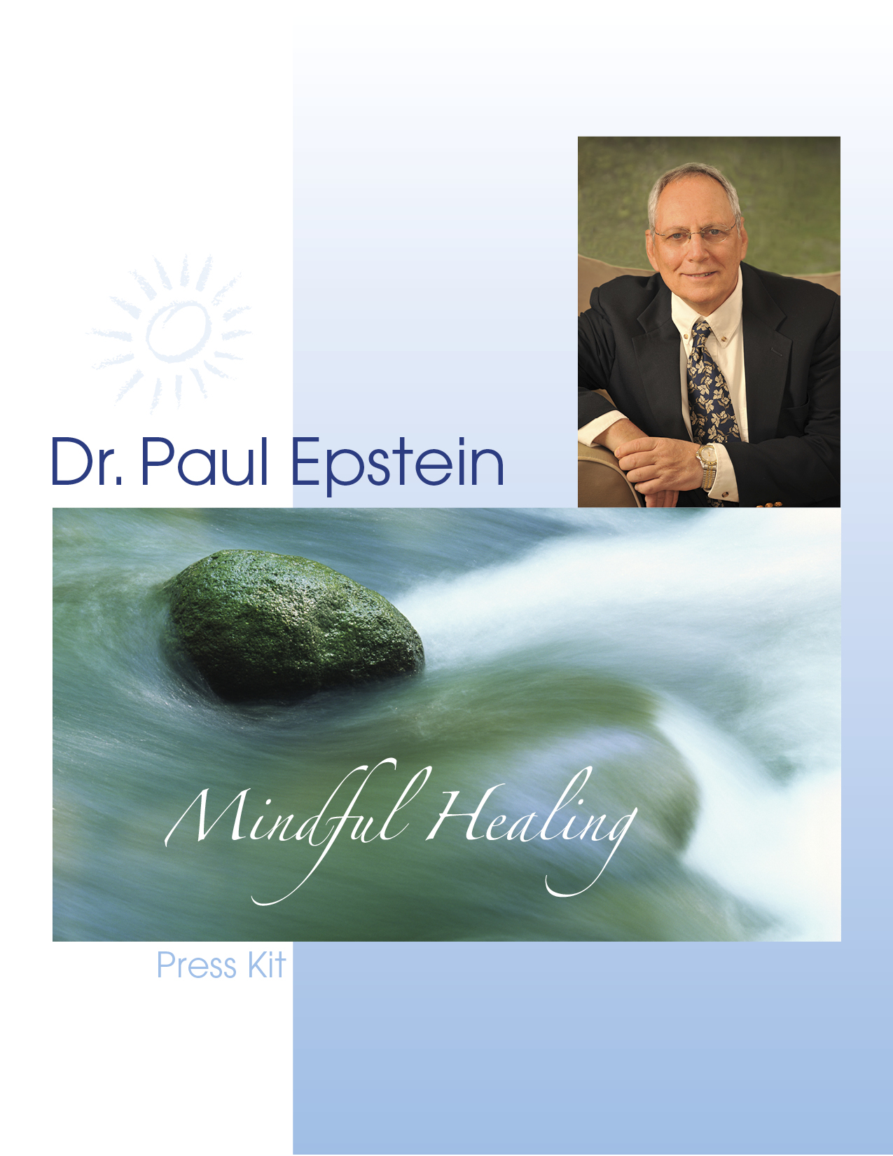

About Dr. Paul Epstein
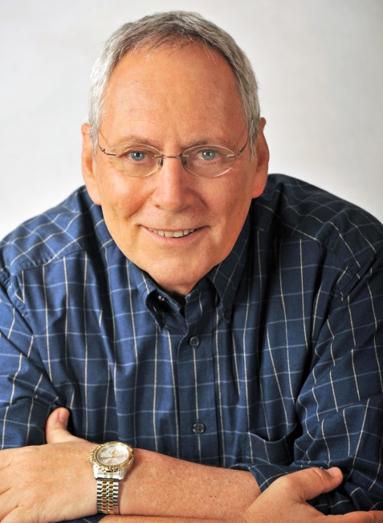
A pioneer and leading voice in Mind-Body Integrative Medicine, Paul Epstein, ND has quietly and persistently been leading the charge to bring awareness to the mind-body connection – and its extraordinary role in healing – for over 30 years.

Dr. Epstein’s passion for Mindful Healing includes treating patients in his private practice, authoring books and articles and traveling throughout the U.S. and internationally to lecture and teach.

It is his fervent belief that pain and illness present an opportunity for profound awakening and that true healing occurs only when the whole person (body, mind and spirit) is included in the healing process. Whereas conventional Western medicine deals primarily with the physical body, psychotherapy focuses primarily on the mind and spirituality has generally been left to the realm of religion, Dr. Epstein has long asserted that all of these facets of the human experience must be listened to and engaged in an authentic self-healing journey.

Whether speaking to a patient, an audience of medical colleagues or the media, Dr. Epstein clarifies that the goal should not be to silence the symptom. Instead, he advocates looking at the symptom from a new perspective. This shift allows the patient to uncover and deal directly, and compassionately, with all that is contributing to their condition. Rather than grasping for a “quick-fix,” this approach gets to the root of the problem to produce a lasting, positive impact on the patient’s life.

As a practicing physician, Dr. Epstein integrates naturopathic medicine with life-changing mind-body therapies including narrative medicine, mindfulness meditation, stress reduction techniques, Buddhist psychology, and contemplative psychotherapy. He mixes the appropriate blend of methods to meet each patient’s specific needs.

As a result of decades of patient care, Dr. Epstein has developed a clear approach and proven methodology. This is not a simple cookie-cutter approach to treating patients. Instead, his Mindful Healing methodology, when applied to each patient individually, helps them access their own unique key – the ‘missing ingredient’ – that unlocks their ultimate healing.
Dr. Epstein often helps people no one else can – patients who have exhausted all other avenues in search of relief. He has mastered the ability to teach other practitioners how to guide their own patients through this powerful process as well.

In addition to his private practice, Dr. Epstein travels worldwide, lecturing and presenting workshops to healing professionals and general audiences. A sought-after keynote speaker, educator and author, Dr. Epstein’s warm and caring approach is far from clinical. Whether speaking to general audiences concerned about their health and wellbeing, university classes or medical groups, his presentations are highly experiential. He teaches how to embrace – and apply – an integrative mind-body approach. He does so simply and clearly with compassion and humor. Audiences are engaged as he guides them to listen and look within, open their minds and hearts and see with new eyes.

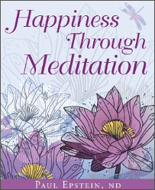
He is a frequent contributor to Naturopathic Doctor News and Review and many other publications. He is the author of the book Happiness Through Meditation, available on Amazon.com.

Dr. Epstein was born in New York City. He received his undergraduate degree in Sociology from Stony Brook University and his ND degree from the National College of Naturopathic Medicine (NCNM). His post-graduate residency program focused on preventive medicine and lifestyle counseling. Dr. Epstein has continued his medical and allied training in psychotherapy, internal family systems, guided imagery and meditation.

Sample Dr. Epstein on Video and Audio

- Television Interview: “Happiness Through Meditation” http://www.youtube.com/watch?v=G90v3o22BBQ

- General Audience presentation:
http://www.youtube.com/watch?v=RxSG86Zp1ZA#t=51

- Professional Audience presentation:
http://www.youtube.com/watch?v=St8ELwra0Fs&feature=youtu.be

- Sample Audio presentations:
http://www.drpaulepstein.com/audio

For Meeting Planners
An original and leading voice in Mindful Healing, Dr. Epstein enlightens, inspires and explains the concept of mind-body medicine, the role of stress in health and illness, how our biography becomes biology and how to use this knowledge on a self-healing path.
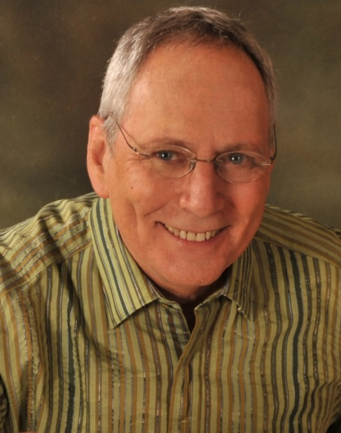
Your group deserves a speaker who connects with his audience, cares about each listener and truly makes a lasting difference with his work and his words.

Dr. Paul Epstein possesses the rare ability to speak to a wide range of audiences. Backed by decades of patient care, study of the mind-body connection and expertise in Mindful Healing, he makes the topic of mind-body integrative medicine relevant and accessible for every audience member.

With a quietly powerful presence, he encourages and empowers each listener to embrace the reality of their life, their story and ultimately find their healing.

Dr. Epstein’s approach to Mindful Healing is clear, proven and inspiring
Whether speaking to colleagues in the traditional medical community and the healing arts – or speaking to a general audience of people interested in their own health and wellbeing – Dr. Epstein offers a depth of wisdom, insight and a crystal-clear perspective.
An engaging style...
a healing message...

“Your keynote resonated with me. It is difficult to find a holistic healer who so masterfully combines the integration of mind and body in such an entertaining, approachable style.”

~ R.G., LCSW, ADTR
He goes beyond the buzzwords that often dilute and marginalize mind-body medicine.

Dr. Epstein guides his audiences to explore deep questions: “How can you tap into your own inner wisdom? What hidden causes might be related to your health challenge? What’s missing in your quest for healing? What does it really look like to take responsibility for your healing with love and compassion?” For Practitioners he addresses the question, “How can you effectively guide, treat and empower your patients to harness the profound healing power of the mind-body connection?”
In Dr. Epstein’s Lectures & Presentations:
- Audience members learn how to shift their mindset to understand the mind-body connection and its importance in the healing process.
- Listeners discover how Mind-Body techniques can support and enhance the conventional Western medical approach to virtually all health conditions.
- Attendees will learn specific ideas and techniques that will help them to take control of their own life and healing process.
- Each audience member is encouraged to consider that they hold the key, inside themselves, that can reveal the missing ingredient in their unique “healing recipe.” Healthcare audiences can leverage this learning to guide their own patients in this process.
- Whether a person is struggling with a health concern or simply interested in improving their own health and wellbeing, they will learn how to tap into their inner wisdom to forge their own healing path.
- In trainings for professionals, practitioners learn how to integrate Dr. Epstein’s mind-body healing approach into their practices. They actually experience these approaches by using the healing techniques on themselves during the workshop. Dr. Epstein encourages practitioners to consciously and courageously engage in their own, ongoing Mindful Healing work in order to be better, more compassionate healers.
- Participants, no matter who they are or where they are on their healing journey, learn powerful tools to make real, lasting changes in their life.
- Every audience member benefits from Dr. Epstein’s inspirational, enlightening and compassionate approach to health and healing.

Why choose Dr. Epstein over other mind-body speakers?
Dr. Epstein has discovered a Mindful Healing approach that is effective for people who have “seen everyone” and “tried everything” in their search for relief. He has perfected the skill for finding the missing ingredient – in their story, in the reality of their life – to help patients unravel the mystery and message in their condition. Dr. Epstein is masterful at identifying the essential ingredients of each patient’s unique “healing soup” and guiding the patient to effectively and compassionately address those elements to dissolve barriers to healing. He knows how to teach individuals to find and accept their authentic healing and how to teach fellow practitioners to personalize and apply the principles of Mindful Healing with their own patients in their own practices.

Popular Keynotes and Workshop Topics
- How Biography Becomes Biology  - Mindful Healing  - The Mind-Body Connection  - Good Medicine is Good Business  - Healing VS Curing: We Need Both | - Illness as an Opportunity  - Mind as Healer – Mind as Slayer  - Meditation as Medication  - Connecting the Cell and the Self  - Cultivating Emotional Resilience

Highlights of Past Speaking and Teaching Engagements

- Academy of Integrative Health & Medicine (AIHM) - Faculty member
- American Association of Group Psychotherapy and Psychodrama (ASGPP)
- American Association of Naturopathic Physicians (AANP)
- Association for the Advancement of Restorative Medicine (AARM)
- Bastyr University
- British Columbia Naturopathic Association (BCNA)
- California Naturopathic Doctors Association (CNDA)
- Canadian College of Naturopathic Medicine (CCNM)
- Center for Self Leadership (Internal Family Systems Conference)
- Connecticut Naturopathic Physicians Association (CNPA)
- Fidelity Investments
- Illinois Association of Naturopathic Physicians Associations (ILANP)
- Institute for Integrative Nutrition
- Israeli Family Therapy Association
- Israeli Naturopathic Medical Association
- Kripalu Center for Yoga and Health
- Lesley University
- LifePath Yoga & Wellness Center
- National University of Natural Medicine (NUNM, formerly NCNM)
- National Institute for Clinical Advancement of Behavioral Medicine (NICABM)
- Naturopathic Medical Students Association (NMSA)
- NBC Sports Group
- New York Association of Naturopathic Physicians (NYANP)
- NY Insight Meditation Center
- Omega Institute for Holistic Studies
- Ontario Association of Naturopathic Doctors (OAND)
- Sivananda Yoga Center and Retreat, Nassau, Bahamas
- Southwest College of Naturopathic Medicine (SCNM)
- Tel Aviv University School of Social Work
- The Graduate Institute
- University of Bridgeport School of Naturopathic Medicine
- University of Virginia Medical School
- Wainwright House

What people are saying...

Speaker and Teacher

“Dr. Epstein is an inspiring and engaging speaker who is able to adapt to each audience to convey his message clearly and simply. His topics – integrative medicine, treating the whole person and stress-related illness – are current and important.”

– Sandra Weinberg, Psychotherapist, Co-founder, NY Insight Meditation Center

“Thank you for your engaging and inspiring presentation! Your presentation and sincerity really set you apart from other speakers. The feedback we received from attendees was extraordinary.”
– James Cavanaugh, Executive Director, Western Industrial Nevada (WIN)

“As a student, I have heard many fabulous presentations. Not one has resonated as deeply as yours. Thank you for your thoughtful, compassionate and unique approach.”
– Elaine C.

“Your lecture on the mind-body connection was phenomenal. Through training, continual effort and experience I hope to help support others on a much deeper level of healing. Thank you for your persistent efforts to make this world a better place.”
– A. F., Student - Institute for Integrative Nutrition

“Your presentation was terrific. I agree with and applaud your approach. Most of all, I enjoyed your warmth, humility and honesty – rare traits these days.”
– A.K., Psychotherapist

Physician
“The physical pain of rheumatoid arthritis led me to Dr. Epstein. Through working with him, the heavy locked door of my psyche opened a crack as I began the long process of letting my pain in so the healing could begin – with Dr. Epstein as my guide.”
– Arline

“Thank you, Dr. Epstein for the wonderful help you’ve given me. I use your teachings every day and see myself shedding thoughts and behaviors that have inhibited me all of my life.”
– Patricia

“Thank you for an inspiring and eye-opening session. It became so clear that my own consciousness is the secret ingredient to my true healing. You have opened new doors for me that I will continue to cultivate.”
– Patient

“Thank you for helping me to understand myself better. I feel unburdened and more peaceful knowing that I have the power and the ability to make this happen for myself.”
– Patty

"When I first came to Dr. Epstein, I had no idea what healing really meant. Now I know. He has shown me how to face and live with cancer and heart problems. His treatment not only co-exists with modern medicine, it is an important adjunct to it. He is one of a kind. He has shown me the road to my healing."
– Patient

Colleagues
“Dr. Epstein is on the leading edge of mind-body therapy. He has merged – in a compassionately unique way – a powerful combination of psychological, biological and spiritual approaches to help people heal and grow.”
– Dr. Steven Karatz, Psychotherapist and Internal Family Systems Trainer

“Dr. Epstein’s synthesis and integration of mind-body healing, Buddhist psychology, guided imagery and natural medicine make him one of today’s most profound teachers and healers. He is my teacher, therapist, mentor and colleague.”
– Nimrod Sheinman, ND, Israel Center for Mind-Body

"Dr. Epstein’s skillful illumination of the mind-body connection encourages us to explore our health challenges from a powerful, profound and holistic perspective. He is an experienced doctor whose approach is proven to facilitate deep transformation and healing at all levels of being. He is a wise and wonderful teacher!"
– Nola Drazdoff, MA, Inspired Path, Inc.

“Dr. Epstein’s commitment to and exploration of the mind-body connection has been unerring. Through natural medicine, meditation and yoga he has mastered the art of mindfulness and awareness to help everyone get to their core. He is a gifted teacher.”
– Wyoma, African Healing Dance Instructor

“Dr. Epstein is the most holistic physician I know. He knows how to help people heal their lives, which consequently helps their bodies and minds heal. I have utilized his expertise with profound effects.”
– Lisa Carberry, ND, CADC
Paul Epstein, ND Resume
42 Richmondville Avenue, Westport, CT 06880
(203) 226-3923
EpsteinMB@aol.com
www.DrPaulEpstein.com

Education & Licensure
Stony Brook University, BA in Sociology (1971)

National College of Naturopathic Medicine, ND (1984)
Residency in Preventative Medicine, NCNM, 1985
Licensure: 1985-present, State of Connecticut, Naturopathic License

Certification & Additional Training
Clinical Interactive Guided Imagery Program
Academy of Guided Imagery, Mill Valley, CA

Certified Yoga and Meditation Teacher
Sivananda Yoga Centers International

Graduate of three year Community Dharma Leaders Program
Spirit Rock Meditation Center, Woodacre, CA

Montessori Early Childhood Certificate Program
Macomb King Harlem College, NY

Psychotherapy and Spirituality Conference
Kripalu Center for Yoga and Health, Lenox, MA

“A Year to Live,” Workshop in Death and Dying with Stephen Levine
Omega Institute for Holistic Studies, Rhinebeck, NY

“Living the Question,” with Sam Keen
Omega Institute for Holistic Studies, Rhinebeck, NY

“Psychotherapy in a Spiritual Context,” with John Wellwood, PhD
Omega Institute for Holistic Studies, Rhinebeck, NY

Student of Swami Vishnu Devananda
author of The Complete Illustrated Book of Yoga

Continued Training
- Mindfulness Meditation
- Stress Reduction Therapies
- Yoga
- Buddhist Psychology
- Internal Family Systems (IFS) Model of Psychotherapy
- Clinical Guided Imagery

Clinical Experience
Director, Health Styles Clinical Program (1984-1985)
Naturopathic Clinic, Portland, OR
Co-Founder and Co-Director (1985 – 1991)
The Center for Holistic Medicine, Norwalk, CT
Director (1991 – 1998)
Center for Mind-Body Medicine, Norwalk, CT
Co-Founder and Co-Director (1998 – 2001)
The Israel Center for Mind-Body Medicine, Ramat HaSharon, Israel
Private Practice (2001 – 2002)
The Naturopathic Center, Norwalk, CT
Private Practice (2002 – present)
Mind-Body Integrative Medicine, Westport, CT

Speaking and Media Experience
Dr. Epstein has keynoted, lectured and led workshops for corporate conferences, professional conventions, university programs and general audiences around the world.

As an original and leading voice in Mind-Body Integrative Medicine, he is a frequently asked to speak on the topics of health and wellbeing, personal growth and his approach for using the mind-body connection to achieve more than a cure: authentic, deep healing.

In addition, Dr. Epstein actively supports organizations that fight domestic violence and veterans groups that address post-traumatic stress disorder.

Dr. Epstein is a frequent guest on television and radio programs. Online, he participates in webinars and teleconferences to discuss Mindful Healing and Mind-Body Medicine.

Publications
Published Articles in Naturopathic Doctor News and Review (NDNR)
“Mind-Body Medicine” (2015)
“Connecting the Cell and the Self: A Mind-Body Approach to Anxiety & Depression (2014)
“Adverse Childhood Trauma: Setting the Stage for Chronic Pain” (2013)
“Childhood Trauma and Adult Disease: What's the Real Diagnosis?” (2013)
“Confessions of a Wounded Healer” (2013)
“Pain as Teacher - Listening to its Meaning, Message and Opportunity,” (2011)
“The Body Remembers and Bears the Burden:
When Biography Becomes Biology” (2011)
“Where’s the Healing?” (2007)

Text Book Chapters
Sheinman N, Epstein P. Mind-Body Medicine. In (Eds: Snider P, Zeff J,Sensenig J, Pizzorno J and Myers S) “The Healing Power of Nature - The Foundations of Naturopathic Medicine and the Ecology of Healing: Primary Care for the 21st Century”. Elsevier, Sydney. (In Press)

Other Publications
Happiness Through Meditation (2012)
Article in Natural Awakenings Magazine (2009)
“Illness as Opportunity to Awaken Consciousness”
Dr. Epstein was featured in Spirituality and Health Magazine (May-June, 2007)
“The Journey of Naturopath Paul Epstein - Healing vs. Curing”
Article in Jerusalem Post (2000)
“The Myth of the Quick Fix”
Article in Jerusalem Post (1999)
“Meditation as Medication”

Contact Information

Address: 42 Richmondville Avenue
Westport, CT 06880

Phone: (203) 226-3923

Email: EpsteinMB@aol.com
Website: www.DrPaulEpstein.com

Social Media:

Facebook: https://www.facebook.com/Paul.Epstein.7509
https://www.facebook.com/DrPaulEpstein

Linked In: https://www.linkedin.com/pub/paul-epstein-nd/b/12b/b48

Twitter: https://twitter.com/truthliberates

Youtube: https://www.youtube.com/user/DrPaulEpstein

Google+: https://www.google.com/+DrPaulEpstein

Photos of Dr. Paul Epstein
A variety of photos are available for the media and event promotions. To access photos in high-resolution, visit http://www.drpaulepstein.com/press-kit, or contact us at (203) 226-3923 or EpsteinMB@aol.com.

